
Faculty of Science and Technology

CST3340
Business Intelligence

Coursework 2

Name : Aye Chan Moe (M00954027)
Term (AY) 2025 - 26

Table of Contents
1. Introduction 3
2. Data Analysis and Visualization 3
2.1 Visualization 1 : Overall Loan Status Distribution 4
2.2 Visualization 2 : Loan Status by Education Level 5
2.3 Visualization 3 : Loan Status by Employment Type 5
2.4 Visualization 4 : Loan Status by Number of Dependents 6
2.5 Visualization 5 : Average Loan Amount by Loan Status 7
2.6 Visualization 6 : Income Distribution by Loan Status 8
2.7 Visualization 7: Credit Score Distribution by Loan Status 8
2.8 Visualization 8 : Loan Term Distribution 9
2.9 Visualization 9 : Commercial Asset Value by Loan Status 10
2.10 Visualization 10 : Relationship Between Credit Score, Income and Loan Status 11
3. Selection of Data Mining Algorithm and Data Pre-processing 12
4. Data Mining 12
4.1 Implementation of the J48 Algorithm 13
4.2 Iteration1 : Full Dataset 13
4.3 Iteration 2 : Removal of Weak Predictors 14
4.4 Iteration 3 : Further Attribute Reduction 15
4.5 Final Model Selection and Interpretation 15
5. Data Ethics 16
6. Conclusion 17
References 17

Introduction
The data that was used in this project is a Loan Approval dataset that was sourced in the Kaggle library and that contained specific information on individual loan applications and whether they were approved or rejected. The data is a normal situation of a bank loan evaluation where the banks consider customers in terms of demographics, employment, salary, credit rating, and asset-based qualities and then make lending decisions. Such data is very applicable to Business Intelligence since the loan patterns can guide banks to enhance the risk assessment, increase the loan approval accuracy and create equitable and transparent lending policies.
The dataset is a combination of categorical (self_employed, and loan_status) and numerical (income_annum, and loan_amount) variables. Such a combination renders the dataset appropriate to explore in Tableau with the aid of visualization and predict with the help of classification algorithms like decision trees in Weka.
The data were first subjected to basic data cleaning procedures before exporting them into Tableau to be able to maintain consistency and clarity. There were no missing values or errors related to data type that were identified during the inspection. Nevertheless, there was one change: the attribute cibil_score was changed to credit_score to enhance clarity and bring the terminology to the general banking terminology, and the dataset is easier to analyze. Every other discipline was maintained in the original form.
The dataset was mostly clean, but a number of other cleaning techniques could have been used in case of necessity. They consist of replacing missing numeric values with the median, replacing missing categorical values with the mode, detecting outliers with boxplots, standardizing category names, and dropping irrelevant identifiers, e.g. loan_id, in the modelling steps. These methods guarantee quality and reliability of data, to enable proper visualization and efficient data mining.

Data Analysis and Visualization
The given section proposes a preliminary discussion of the Tableau analysis of Loan Approval data. In order to investigate the main variables and discover the patterns leading in loan approval decisions, ten visualizations were developed. The analysis will start with the general descriptive charts and further on to the finer comparisons and relationships among the financial features, demographics and loan approval success. These findings can be used to help explain the influence of various applicant characteristics on lending decisions and aid banks to make more informed and data-driven judgment.

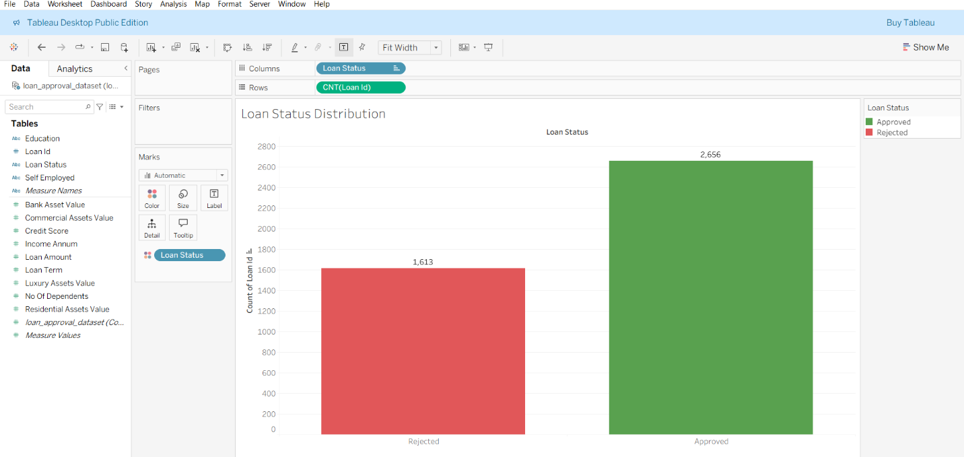
Visualization 1 : Overall Loan Status Distribution

The initial visualization is a simple description of the dataset as it presents an overview of the total number of approved and rejected loans applications. Bar chart indicates that there are more approvals compared to rejections; hence this is a dataset that is quite balanced in distribution. This balance is advantageous to future data mining since it minimizes model bias. In business terms, the initial overview indicates that all approval decisions are not the same and it can be argues that applicant characteristics have a significant impact on the outcome.

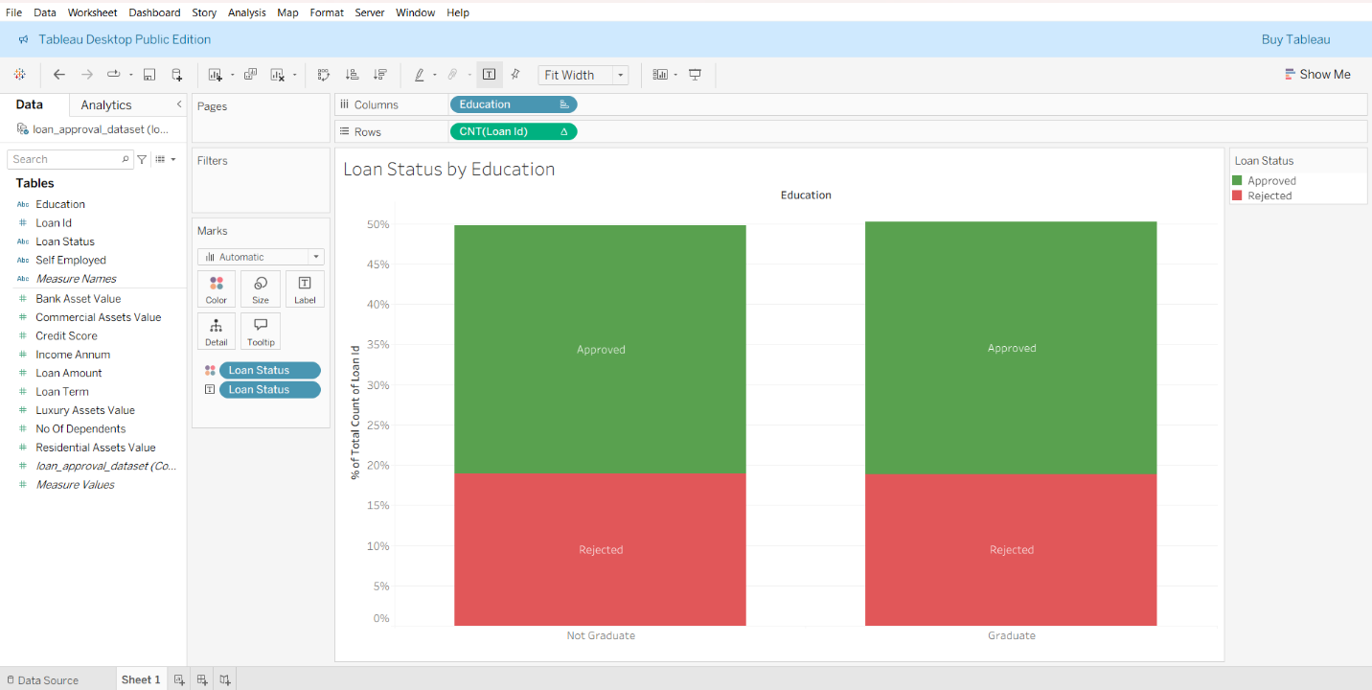
Visualization 2 : Loan Status by Education Level

The comparison was done to find out the rates of loan approvals based on the type of education (Graduate and Non Graduate). The outcomes demonstrate that the approval rate of graduates is significantly higher in comparison with that of non-graduates. This implies that level of education can be linked to a more stable job or greater earning capacity, which are the desirable factors to lenders. This knowledge can be applied by banks to customize risk evaluations or suggest further screening of applicants who might lack formal qualifications.

Visualization 3 : Loan Status by Employment Type

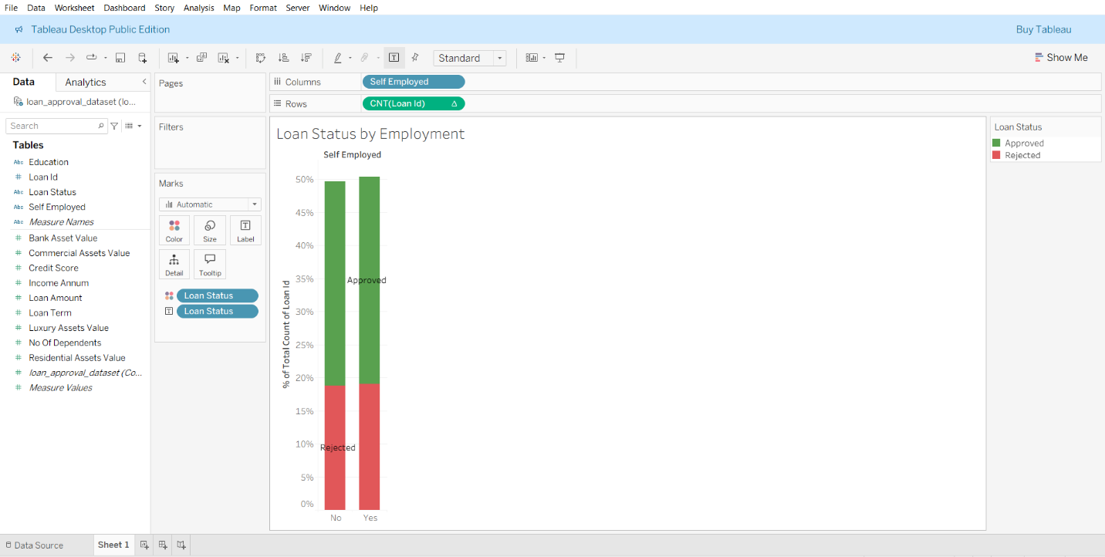
The following visualization will make comparisons of the approval rates among self-employed and non-self-employed applicants. As this bar chart shows, salaried applicants are much more likely to be approved. This is not surprising considering that banks usually prefer those who have fixed sources of income. In the case of self-employed people, revenue might be unstable, which creates an additional risk. This trend may imply that financial institutions will be able to modify their assessment model to treat self-employed borrowers more equally by reviewing other supporting documentation or cash-flow statements.

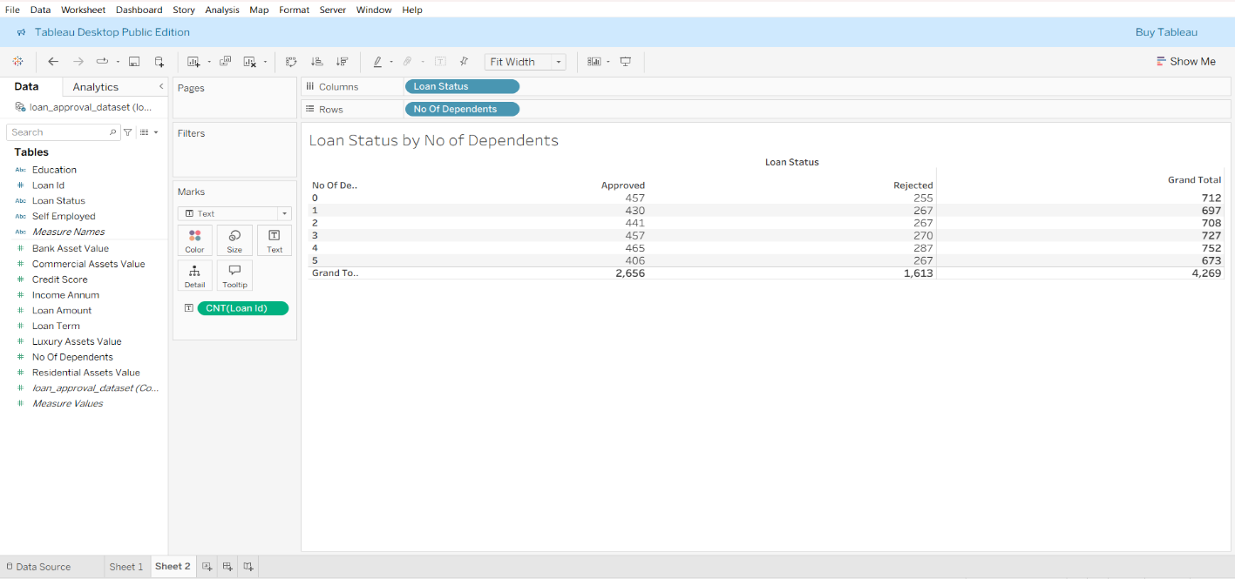
Visualization 4 : Loan Status by Number of Dependents

Approval decisions are shown in a grouped bar chart depending on various dependent categories. The findings show that the applicants who have less dependents (0-1) are more likely to be approved. The approvals to applicants who had three or more dependents are on the decline implying that higher financial commitments can lower the disposable income and raise the risk of repayment. Awareness of this trend will help the banks to better include household size in their affordability calculations.

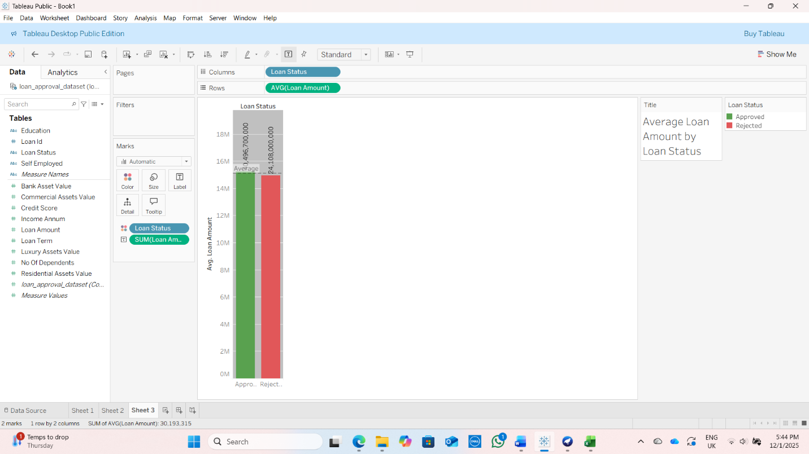
Visualization 5 : Average Loan Amount by Loan Status

The graph indicates that approved applicants are likely to borrow a small amount of money as compared to those that are rejected. The reference line reflects the total average amount of loans and shows that those that are rejected are going to be placed above this figure. This is an indication that more loan requests will be linked to the lending risk that will cause higher rejections.

Visualization 6 : Income Distribution by Loan Status
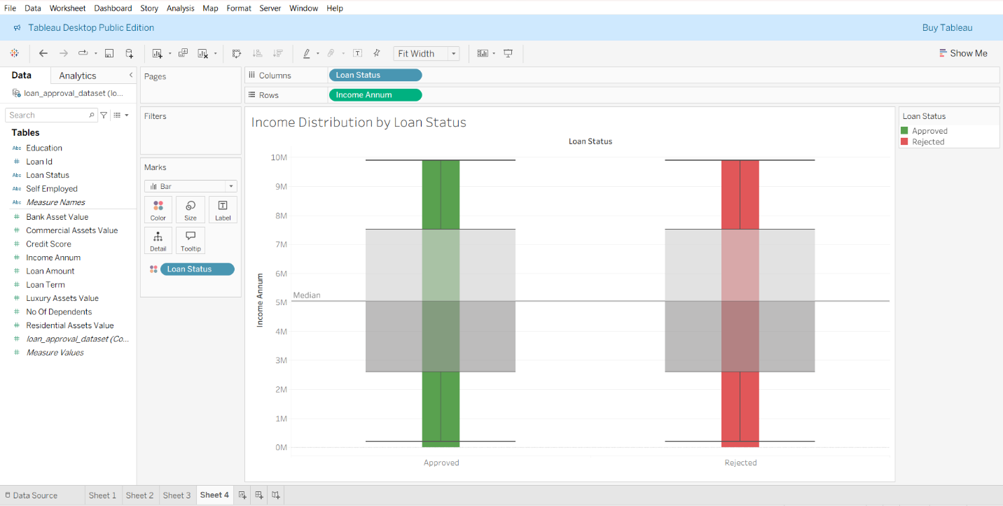

As the boxplot demonstrates, approved applicants tend to have a higher level of income than rejected applicants. Approved loans have a significantly higher median income and a larger range, meaning that income is an important factor in the loan approval process. Banks can use such information to refine income-based eligibility thresholds or adjust policies for low-income applicants.

Visualization 7: Credit Score Distribution by Loan Status
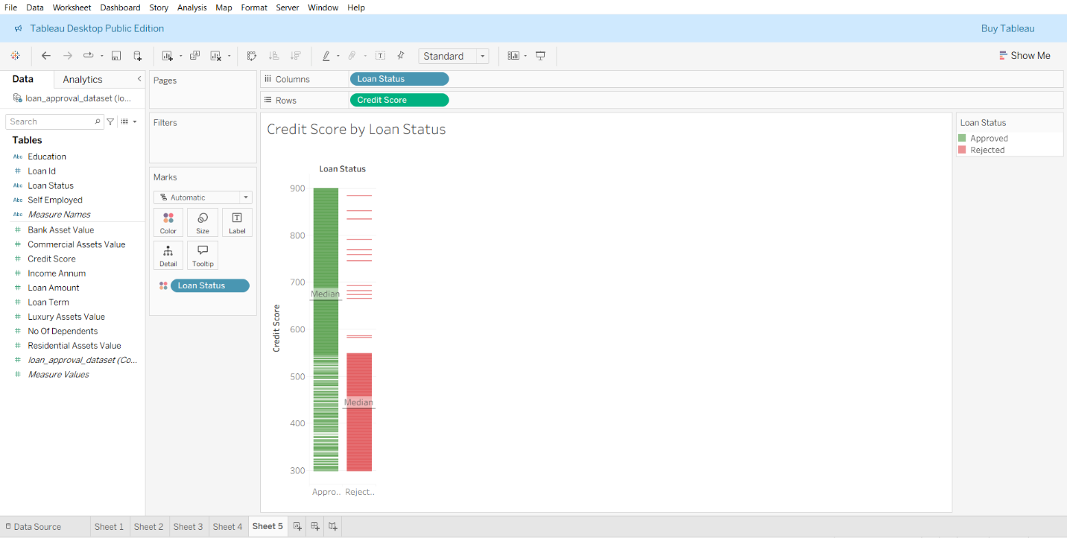
One of the most critical factors in lending is credit scores, and the boxplot confirms that approved applicants have higher credit scores always. The dissemination of values indicates that low credit ratings are considerably connected with rejection rates. This is the basic understanding of predictive modelling. It also follows the need to be a good credit behavior thus banks can use this to steer financial education programs to customers.

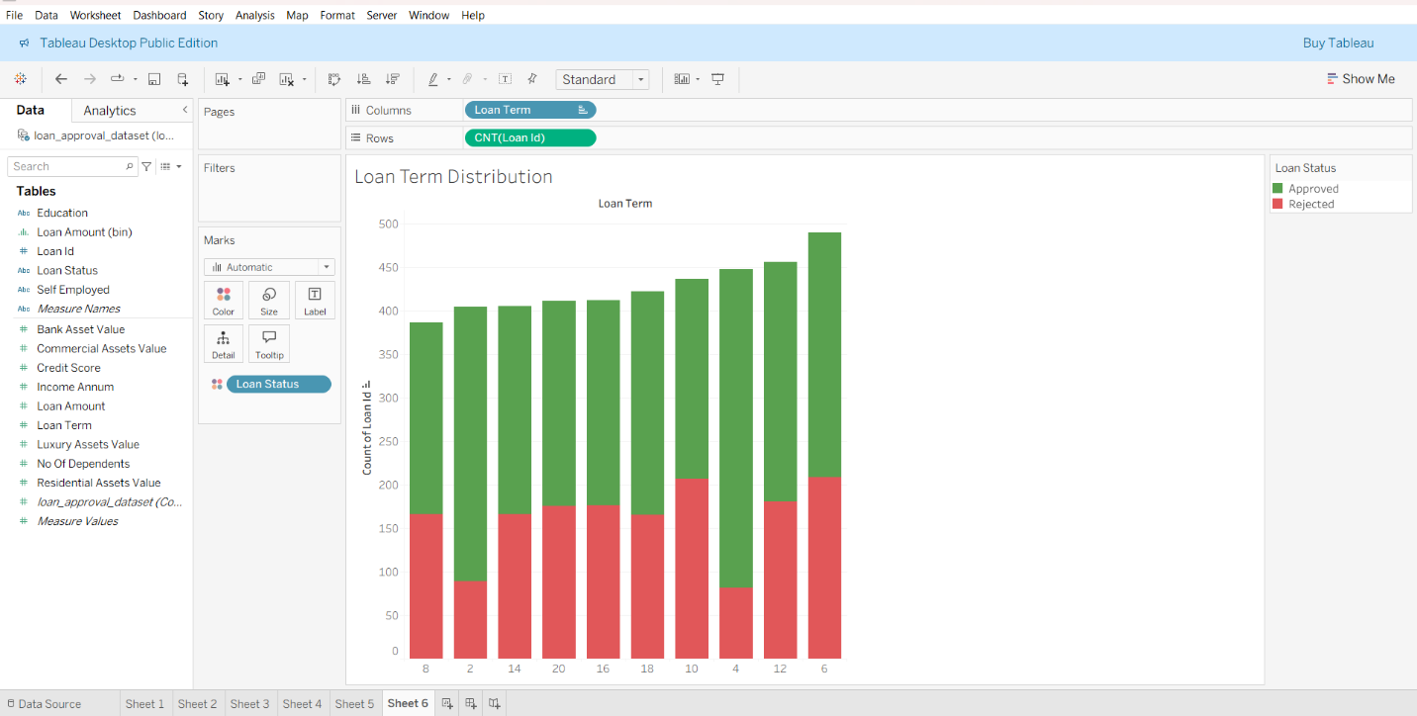
Visualization 8 : Loan Term Distribution

Histogram of the loan terms shows that the standard terms of borrowing are popular, and the majority of applicants choose the short, standard, and long terms. Even though the loan term alone does not directly give the likelihood of approval, it gives context in which the applicant behavior can be understood. As an example, candidates who want to have shorter terms might have to pay more per month, but have reduced expectations of the total interest.

Visualization 9 : Commercial Asset Value by Loan Status
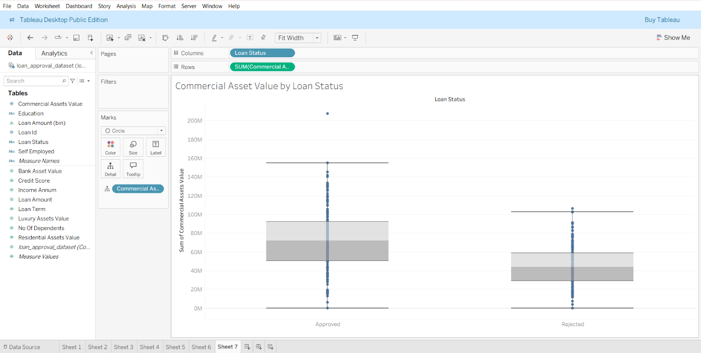

The boxplot involves comparison of commercial assets of rejected and approved borrowers. In general, the approved applicants have much higher values of assets, and the median and upper quartile are higher by far, compared to the rejected applicants. The greater dispersion among approved applicants implies that there is a greater diversity of commercial wealth whereas rejected applicants are much concentrated with less high values as outliers. This trend indicates that increased commercial assets ownership has powerful impacts on approval decisions in that lenders tend to consider such assets as a sign of financial stability and decreased repayment risk.

Visualization 10 : Relationship Between Credit Score, Income and Loan Status
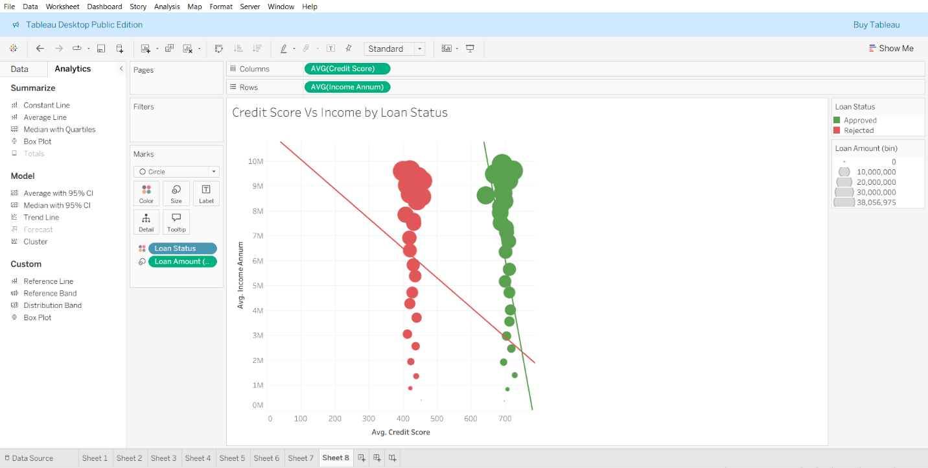
This graph indicates the relationship between credit score and income and the result of loan approvals. Greater bubbles indicate greater amounts of loans. The approved applications are concentrated on higher income and credit score levels, whereas, rejected applications are concentrated at the lower ranges. The trend lines indicate that there is a positive relationship between financial strength and the probability of approval, which is strong.
In all the visualizations, the analysis indicates that there is a common pattern: those applicants that are approved tend to have a higher financial health. They are likely to be earning more money, with better credit reports, more commercial, residential, luxury, and bank asset values, less dependents, and more consistent loan agreements. There is a higher probability of loan being approved with better financial indicators and rejected applicants usually record lower values in the same measures. These results affirm that lenders give a lot of importance to the general financial stability and strength of asset of an applicant when judging loan applications.

Selection of Data Mining Algorithm and Data Pre-processing
To proceed with the analysis of the dataset of loans approval, the Decision Tree classifier is chosen as the most appropriate data mining algorithm. A Decision Tree is a predictive model that predicts the membership of a class, here the Loan Status (Approved or Rejected), by repeatedly dividing the data, using the predictor variables that most effectively divide classes. It operates by choosing attributes that have the largest information gain or Gini reduction, which create a tree-shaped structure that is easy to interpret and explain.
The algorithm is suitable due to the visualization outcomes which provide the presence of a rule-like pattern between applicant traits and the outcomes of loan approval. As an example, the boxplots of income, credit score, and asset values all have higher distributions among approved applicants. Credit score, income, and amount of loan are also strongly related as shown by scatterplots, whereas stacked bar charts demonstrate clear distinctions between risk-related variables like the number of dependents. These visual patterns imply that approval decisions are made based on a mix of threshold based conditions- precisely the kind of relationships that the Decision Trees represent well.
The main predictor variables are Income Annum, Credit Score, Loan Amount, Number of Dependents, Residential Assets Value, Luxury Assets Value, Commercial Assets Value, Bank Asset Value and Employment Status where the class variable is the Loan Status.
The data set has minor aberrations, including missing values and extreme values of assets. Missing values may be addressed by imputation or elimination based on their frequency. Outliers can be put on a cap or be log-transformed to have a more robust model, but Decision Trees are usually resilient to skewed data.
Without further pre-processing, another transformation to consider is that of the continuous variables discretizing them, which can increase the interpretability of Decision Trees, and can sometimes improve splitting decisions.

Data Mining
The section uses the J48 decision tree algorithm in Weka to further subdivide the pre-processed loan approval data. The decision trees should fit this issue since the target variable which is the loan status is categorical and in various previous visualizations, there were some clear threshold points based relationships between the predictors including credit score, income, loan amount and loan term. Decision trees are also very interpretable and hence the banks are able to know the decision-making logic and justify lending recommendation.

Implementation of the J48 Algorithm
Weka is an implementation of C4.5 tree-building algorithm, which is called J48. It operates in consist of recursively picking the attribute with the highest information gain and subsequently splitting the data into branches according to threshold values. This is done until additional splits do not increase the accuracy of the model, resulting in a pruned tree that balances between model performance and complexity. J48 would be suitable in this task, since the data set is a mixed set of continuous and categorical elements, and the model is designed to cope with non-linear decision boundaries, a trend already apparent in the previous visualizations.
The model was run 3 times as it was necessary with a 70 percent training / 30 percent test split where performance was measured by accuracy, confusion matrix, Kappa statistic, and error.

Iteration1 : Full Dataset
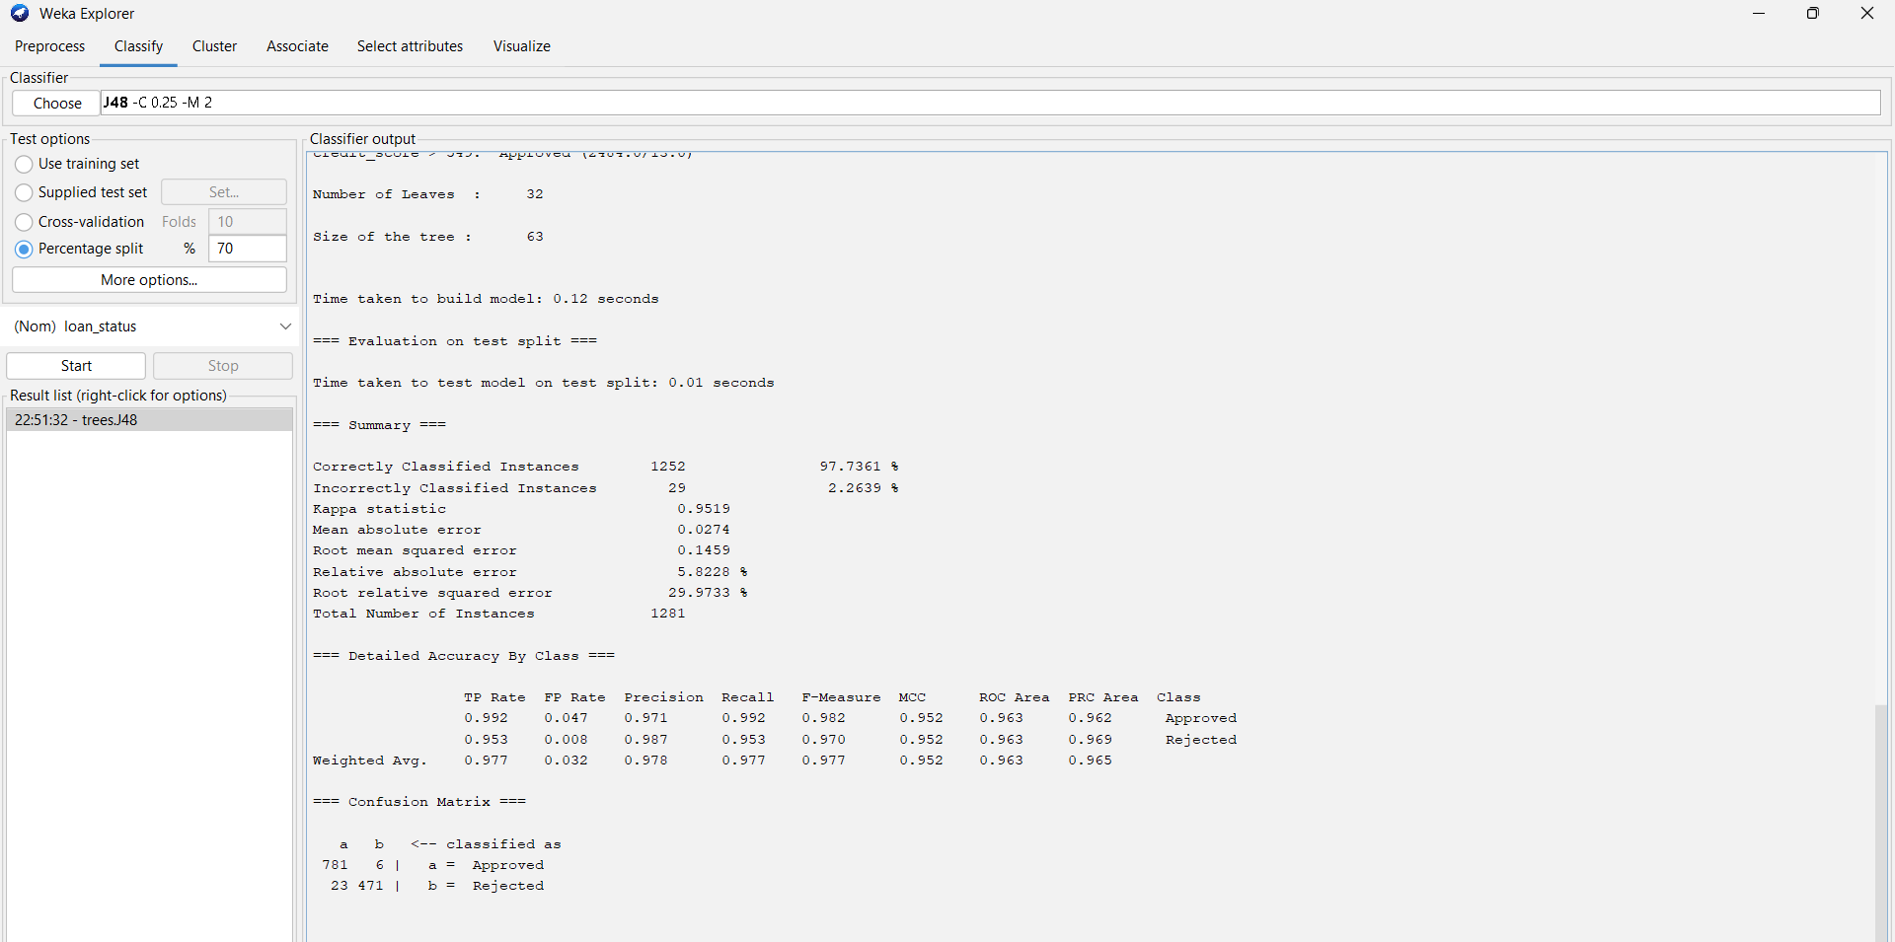
The initial one took into account all the possible predictor variables, such as education, sel_femployed, luxury_assets_value, and no_of_dependents. The resulting generated tree contained 63 nodes, which is a relatively complex model. The accuracy was high (97.74) as well as the Kappa value (0.9519) and both classes had equal performance in terms of accuracy and recall. The confusion matrix reflected that there were only 29 misclassified records amongst 1,281 test records.
Analysis of the tree indicated that credit_score was the root node which has confirmed it to be the most significant predictor as earlier implied by the scatterplots and bubble charts. Income, amount of loan, residential assets were the other key determinants. Education and self_employed were only present in more advanced branches with weak splits implying that they have little predictive power.

Iteration 2 : Removal of Weak Predictors
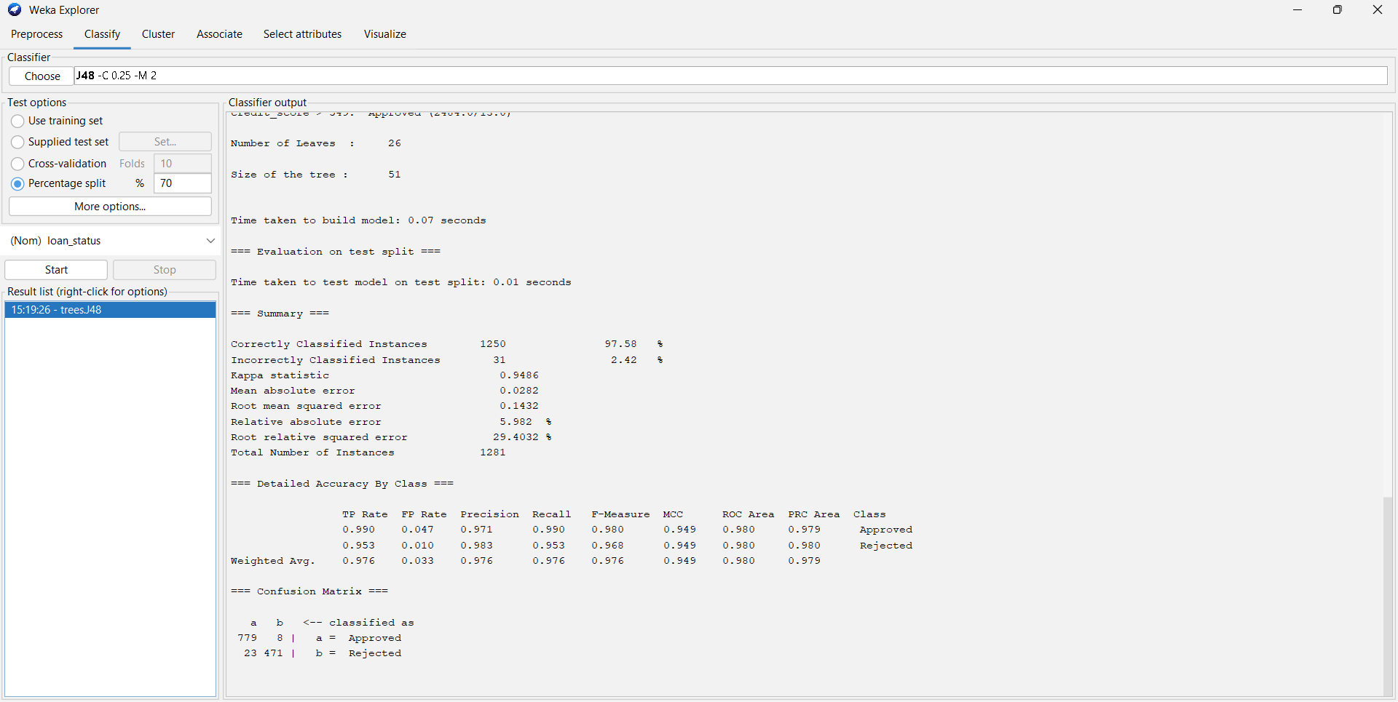
Considering the experience gained during Iteration 1, education and luxury_assets_value were eliminated because they played a minor role in the organization of the initial tree. The new model generated a slightly smaller tree with 51 nodes with an accuracy of 97.58%. Despite a slight reduction in performance, the model was very stable, and the Kappa of the model was 0.9486.
This version ensured that the elimination of two variables did not affect the predicting power of the model much. Once more, credit score, income, and amount of loan prevailed in the splitting structure. The slight variation in performance reinforced the position of eliminating these poor qualities.

Iteration 3 : Further Attribute Reduction
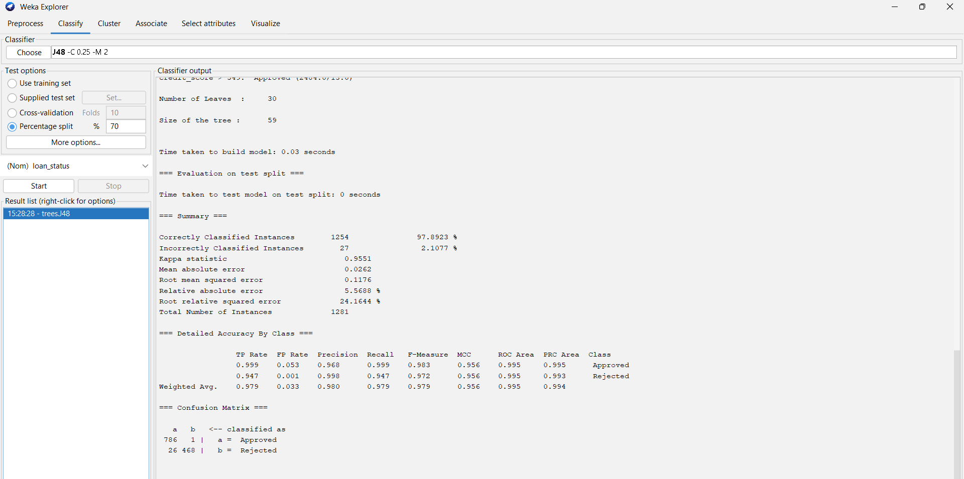
In the third version, two more low impact variables, such as self_employed and no_of_dependents were dropped. This generated a cleaner dataset that was determined to be the strongest predictors detected in the visualizations and previous tree structures.
This model performed the best among all the iterations and the accuracy of the model was 97.89 percent, the Kappa was the greatest (0.9551) and the error measures were the least. This was a smaller tree size of 59 nodes, which provides a better trade-off between simplicity and predictive power. The lowest number of errors of all of the runs was 27, reported in the confusion matrix.
The tree structure supported previous results:
- Applicants who had credit_score exceeding 549 were mostly granted.
- The rejections were caused by the high amount of loans and low income.
- When income and the amount of loans was on the border, residential, commercial, and bank asset values had a positive contribution.

Final Model Selection and Interpretation
Iteration 3 was chosen as the final model since it has the highest predictive accuracy, best generalization and the most comprehensible. Elimination of weak variables enhanced the performance by eliminating noise and concentrating the model on the real influential predictors.
In general, it can be explained that the final J48 model has a high predictive power, and it is highly correlated with the trends in previous visualizations. The credit score, income and the amount of loan are the most dominant predictors of the loan approval. Use of asset values gives further discrimination in borderline cases, and demographic variables insignificant role.
The large accuracy, large Kappa value and small error measures imply that the decision tree fits the data very well. In addition, it is transparent in its structure, which offers an interpretable basis to make financial decisions and justify the same policies of loan approvals.

Data Ethics
The analysis of business datasets, and especially the ones that deal with sensitive financial data like credit scores, income levels and loan approval results, are ethically crucial. One of the ethical concerns is fairness: the data-driven models should not support the bias and discriminate against a specific group of people. As an example, one might consider income or employment status as attributes that might be used to the detriment of lower-income applicants unintentionally. Ethical analysis involves the verification of some bias tendencies, making model decisions transparent, and the way of the predictive results that are taken, especially in the case of decision trees.
Legally, organizations should adhere to data protection laws including the GDPR(General Data Protection Regulation) that regulates the collection, storage and processing of personal data. This extends to making sure that data has been acquired initially with the permission of the consent of the data, anonymized where necessary and used solely in business-related causes. The outputs of the model should not be applied in a manner that infringes the rights of the individuals, e.g. automated decisions without a review or explanation options. Also, financial information is covered with industry-specific regulations, which presuppose fairness of credit decisions and their accuracy.
Professional considerations are associated with being of high standards of practice in dealing with data. Analysts should not break the confidentiality, manipulate the results to get good results and they should make sure their methods are suitable and they report them correctly. Professional codes, including those that were noted on the data ethics lecture, focus on accountability, transparency and responsible sharing of insights. Such limitations as possible data quality problems or biasness in the dataset should be clearly admitted by the analysts and should not overstate the accuracy of the model.

Altogether, the ethical, legal, and professional requirements collaborate with each other to make sure that the data analysis leads to the fair, transparent, and responsible business decisions and the rights and interests of people are not violated.

Conclusion
The visualization analysis showed stable and significant patterns in the loan approval data. In all the charts, the successful applicants had better financial profiles, such as higher income, credit scores and asset values, which verify the high power of financial stability on the outcome of lending. The given findings can be backed with the existing concepts of business analytics, which emphasize the usefulness of visual data exploration to identify trends and inform the organizational decision-making process (Few, 2012; Knaflic, 2015). These patterns could be also explained by broader literature that predictive variables in lending tend to incorporate the indicator of creditworthiness and affordability (Thomas, Crook and Edelman, 2017).
These observations were supported by the data mining stage. The J48 decision tree algorithm (Witten, Frank and Hall, 2011) was used in three iterations, eliminating less powerful predictors of the dependent variable. The last model had the best accuracy (97.89) and highest value of Kappa which means that there is a good fit of the model and that it has a good predictive power. The credit score turned out to be the most significant predictor, then income, loan amount and core asset measures, which is in line with the thought of the existing decision-tree studies, which underline the importance of informative splits in classification tasks (Quinlan, 1993). Elimination of non-influential features resulted to a more efficient and understandable model.
The generated insights provide viable business intelligence to the financial decision-makers. It has also been discovered that predictive analytics helps a great deal in strategic decision-making within an organizational setting (Davenport and Harris, 2007; Chen, Chiang and Storey, 2012). These findings can be used by loan managers to make credit policies more refined, the risk analysts can detect high-risk applications earlier, and product designers, can differentiate lending products to specific applicant profiles. In general, visualization and predictive modelling as a combination present a powerful and informative framework that underpins transparent, fair and operationally efficient loan approval practices.

References
Anderson, R., 2007. The Credit Scoring Toolkit: Theory and Practice for Retail Credit Risk Management and Decision Automation. Oxford: Oxford University Press.
BCS, 2020. BCS Code of Conduct. Available at: https://www.bcs.org/membership/become-a-member/bcs-code-of-conduct/ (Accessed: [3 December 2025]).
Chen, H., Chiang, R.H.L. and Storey, V.C., 2012. ‘Business Intelligence and Analytics: From Big Data to Big Impact’, MIS Quarterly, 36(4), pp.1165–1188.
Davenport, T.H. and Harris, J.G., 2007. Competing on Analytics: The New Science of Winning. Boston: Harvard Business School Press.
Fayyad, U.M., Piatetsky-Shapiro, G. and Smyth, P., 1996. ‘From Data Mining to Knowledge Discovery in Databases’, AI Magazine, 17(3), pp.37–54.
Few, S., 2012. Show Me the Numbers: Designing Tables and Graphs to Enlighten. Burlingame: Analytics Press.
Floridi, L. and Taddeo, M., 2016. ‘What is data ethics?’, Philosophical Transactions of the Royal Society A: Mathematical, Physical and Engineering Sciences, 374(2083), pp.1–5.
Han, J., Kamber, M. and Pei, J., 2012. Data Mining: Concepts and Techniques. 3rd ed. Waltham: Morgan Kaufmann.
IEEE, 2019. Ethically Aligned Design: A Vision for Prioritizing Human Well-being with Autonomous and Intelligent Systems. IEEE Standards Association.
Information Commissioner’s Office (ICO), 2021. Guide to the UK General Data Protection Regulation (UK GDPR). Available at: https://ico.org.uk/for-organisations/data-protection-and-the-gdpr/ (Accessed: [3 December 2025]).
Knaflic, C., 2015. Storytelling with Data: A Data Visualization Guide for Business Professionals. Hoboken: Wiley.
Mittelstadt, B.D., Allo, P., Taddeo, M., Wachter, S. and Floridi, L., 2016. ‘The ethics of algorithms: Mapping the debate’, Big Data & Society, 3(2), pp.1–21.
O’Neil, C., 2016. Weapons of Math Destruction: How Big Data Increases Inequality and Threatens Democracy. New York: Crown.
Quinlan, J.R., 1993. C4.5: Programs for Machine Learning. San Francisco: Morgan Kaufmann.
Royal Statistical Society (RSS), 2019. Code of Conduct and Ethical Guidelines. Available at: https://rss.org.uk (Accessed: [3 December 2025]).
Tan, P.N., Steinbach, M. and Kumar, V., 2019. Introduction to Data Mining. 2nd ed. Harlow: Pearson.
Thomas, L.C., Crook, J.N. and Edelman, D.B., 2017. Credit Scoring and Its Applications. 2nd ed. Philadelphia: SIAM.
Tufekci, Z., 2015. ‘Algorithmic harms beyond Facebook and Google: Emergent challenges of computational agency’, Colorado Technology Law Journal, 13(203), pp.203–218.
UK Government, 2018. Data Protection Act 2018. London: The Stationery Office.
Voigt, P. and Von dem Bussche, A., 2017. The EU General Data Protection Regulation (GDPR): A Practical Guide. Cham: Springer.
Witten, I.H., Frank, E. and Hall, M.A., 2011. Data Mining: Practical Machine Learning Tools and Techniques. 3rd ed. Burlington: Morgan Kaufmann.
Zhang, H., 2016. ‘The Optimality of Naïve Bayes’, AAAI Technical Report, 1, pp.3–9.

